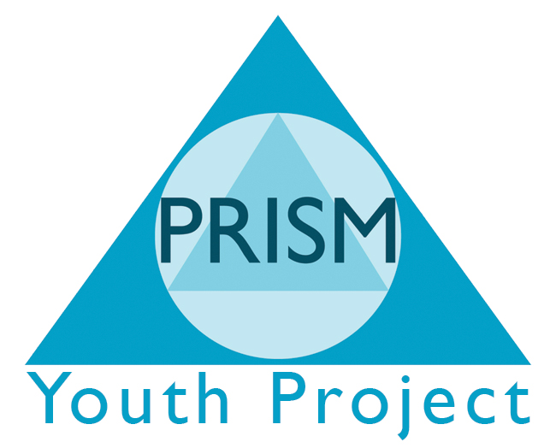

PRISM Independent School

Curriculum Policy Statement

A dynamic, creative curriculum creates opportunities for young people to develop self esteem, confidence, life skills, team work and communication alongside a vocational subject which allows the young people to achieve their potential.

PRISM Independent School’s curriculum inspires all young people to become:
- successful learners – who enjoy learning, make progress and achieve
- confident individuals – who are able to live healthy, safe and productive lives
- responsible citizens – who make a positive contribution to society.

Unique opportunities for unique young people

