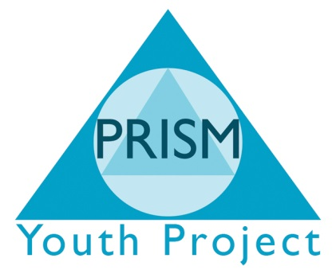

Access to Fair Assessment Policy
Statement of Assessment
- PRISM Youth Project and Independent School aim to provide a variety of qualifications which provide all students with the opportunity to achieve their full potential by the most appropriate and direct route.
- Our Assessment Policy is based on the concepts of equality, diversity, clarity, consistency and openness.
- We will endeavour to ensure that the assessment processes are implemented in a way which is fair and non-discriminatory.
Access
Students are made aware of the existence of this policy and have open access to it. It can be found in the main offices of each site and a hard copy can be requested from the Site Coordinators or the Senior Management Team.
All tutors are made aware of the contents and purpose of this policy through annual training.
This policy is reviewed annually and may be revised in response to feedback from students, tutors and external organisations.
What students can expect from PRISM
- We aim to ensure that all assessment of work is carried out fairly and in keeping with the awarding body’s requirements.
- All portfolio-based work will be assessed fairly against the qualification standards and teachers involved will be fully trained.
- Internal assessments will be carried out fairly and according to awarding body instructions.
- Externally marked tests and exams will be according to the requirements of the awarding body.
Students can also expect:
- To be fully inducted onto a new course and given information that can be shared with parents and carers.
- Learning outcomes, performance, criteria and other significant elements of learning and assessment to be made clear at the outset of the course and when assignments are set.
- To be given appropriate assessment opportunities during the course with feedback provided on the quality of the work.
- All work to be marked within two weeks of submission by the student.
- Where equivalents and exemptions can be applied, ,we will ensure this is pursued with the relevant awarding body.
Cheating and Plagiarism
A fair assessment of student’s work can only be made of that work is entirely the student’s own. Therefore students can expect an awarding body to be informed if:
- They are found guilty of copying, giving or sharing information or answers, unless part of a joint project
- They use unauthorised aid during a test or examination
- They copy another student’s answers during a test or examination
- They talk during a test or examination.
All allegations of cheating and plagiarism will lead to a full investigation which will follow the guidance of the relevant awarding body.
If a student feels he/she has been wrongly accused of cheating or plagiarism, they should be referred to the Complaints Policy.

