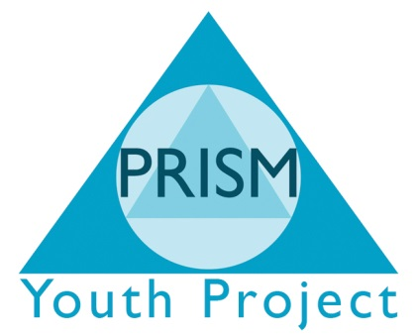

Appeals Policy
Introduction
This policy addresses the situation where student may wish to appeal against a grade he/she has received for a qualification.
Access
Students are made aware of the existence of this policy and have open access to it. It can be found in the main offices of each site and a hard copy can be requested from the Site Coordinators or the Senior Management Team. Alongside PRISM’s appeals policy are the appeals policies for each of the awarding bodies used by PRISM. All staffs receive full training on PRISM’s Policies in order that students can be supported.
This policy is reviewed annually and may be revised in response to feedback from students, staff, parents and external organisations.
Policy Statement
All students at PRISM Youth Project and Independent School have the right to make an appeal about any of the marks received for the qualifications they are undertaking.
If any student wishes to appeal a decision, they should follow the following procedure.
- If possible, speak to the member of staff responsible for teaching the qualification in the first instance about the reason they wish to appeal.
- The member of staff has a responsibility to explain to the candidate why he/she received the grade/mark.
- If the student is not satisfied with the explanation, the piece of work will be re-marked by another member of staff also involved with that qualification.
- The student will be informed of the outcome of the re-marking by letter.
- If the student wants to continue the appeal, he/she needs to contact the Deputy Head, who will provide the student with information about the appeals procedure for the relevant awarding body and explain what is involved. The Deputy Head will assist with the completion of any forms and will correspond with the awarding body on behalf of the student.
- Please note: a student must have the support of the centre to be able to appeal against a result.

