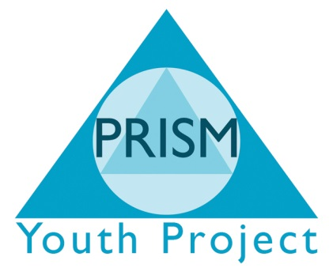

Complaints Procedure
We welcome feedback both positive and constructive at any time during your involvement with our school and associated projects.
Prism Independent School is committed to providing high quality education to all our learners. When something goes wrong we need our learners to tell us so that we can continually improve our standards. We also need to be approachable and accessible so young people, parent, carers and partnership agencies feel that their concerns will be taken seriously. We hope our complaints procedure will fulfil these aims.
The procedure is as follows:
- Contact the school office on 01274 487633 or email info@prismyouthproject.org
- Explain in the nature of the complaint
- If your contact cannot resolve the complaint they will ensure that the relevant person contacts you and endeavours to resolve the issue.
- If you are still not satisfied, we shall send you an official complaints form that needs to be returned to the school office.
The stages of complaints
- Stage 1 – Complaint dealt with informally by staff member (who is not the subject of the complaint)
- Stage 2 – Written complaint dealt with by Executive Head (or Chair of Management Committee if the Executive Head is the cause of concern or has been involved previously) This will be actioned by a an official complaints form.
- Stage 3 – Complaint heard by Management Committee’s complaints appeal panel.
An unsatisfied complaint can always take a complaint to the next stage.
Time Limits
All formal written complaints will be acknowledged within 2 working days explaining
- Who will investigate the complaint
- Who will decide on the validity of the complaint
- The right of appeal (where applicable)
- The likely time scale
The usual timescale for investigation will not exceed one week. If there is a delay beyond a week, contact will be made with the complainant.
Unless there are exceptional circumstances, all complaints will be dealt with, within 15 working days and we will write to you with a detailed response.
PRISM will always try to resolve complaints quickly and to use the information we receive to minimise the causes for complaint. We recognise that we cannot resolve all complains and that solutions will sometimes require a compromise, e.g. after a disagreement between learners.
Appeal
If you are not satisfied with the response to a written complaint there is provision for establishment of a hearing in front of a panel appointed by the proprietor of at least 3 people who has not been directly involved in the matter detailed in the complaint.
The panel will consist of:
- 2 members of the management committee
- 1 person who is independent of the management of the School.
The young person, parent/carer or referring agency is allowed to attend the hearing and be accompanied by a person of their choice.
The panel will make findings and recommendations in writing and a copy of this document will be hand delivered or sent to you by mail or electronic mail. A copy will be held on the school premises and made available for inspection by proprietor or OFSTED if requested.
Written Records
Written records of all complaints will be kept confidentially in the Senior Management Team Office and will clearly state:
- The type of complaint
- If resolution came at a preliminary stage
- Whether the complaint was dealt with at Panel
- Finding and recommendations
Annual number of complaints will be available on the PRISM Independent School website.

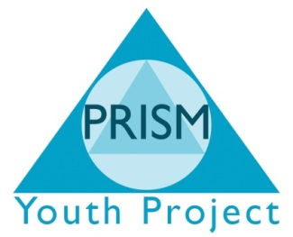
PRISM Independent School
Complaint form
Name of person making complaint | Date complaint was made:
Type of complaint:

Details of complaint – please be as detailed as possible, giving names and dates.

PRISM Independent School - Only
Date complaint received: | Complaint passed to:  Date:
Investigation notes attached
Yes No

Brief summary of recommendations

Letter sent to complaint:
Yes No
Date:

Copy of Letter attached:
Yes No

Complaint resolved:
Preliminary Stage Panel Hearing

