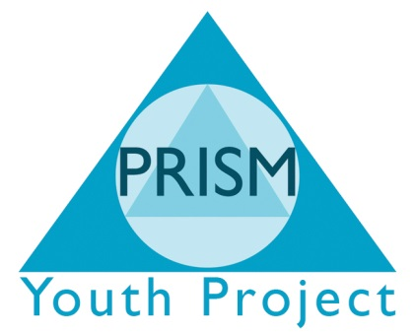

Confidential Policy
Intention
PRISM Independent School has developed this policy as part of a commitment to the development and implementation of the Equal Opportunities Policy of the organisation.
The principal aims of the policy are to safeguard the rights of young people accessing services and employees/volunteers. This will incorporate confidentiality and privacy whist ensuring consistency of good practice throughout the organisation.
It is good practice to explore the understanding of confidentiality whilst working face to face with young people either in one to one or group work settings. Agreement should be reached between parties as to the boundaries of confidentiality. PRISM Independent School recognises that there are circumstances where a young persons rights to make choices will need to be challenged/over-ruled.
This becomes relevant to our work with young people in respect of child protection. Young people should be aware of PRISM Independent School’s Confidentiality statement
“PRISM Independent School believe that you have the right to privacy and safety, we strive to provide a place where you feel at ease to talk about yourself.”
There may be situations where we may have to share information with people outside this project in order to protect your safety. We will only do this when we feel you, or another person is likely to come to some harm or is being hurt.
- You or someone you know is being sexually, physically or emotionally abused.
- You or someone you know is being threatened with violence.
- Where the life of you or a third party is at risk
We will not pass on any information about you without discussing it will you first.
NB Failure to obtain consent will not constitute a reason for not passing on information.
(See child protection policy for further information/guidance)
Employees
PRISM Independent School employees should never divulge colleagues personal circumstances to anyone without the permission of the individual concerned, except in the case of information passed to the line manager whereby such information may pertain to that employee’s welfare or the performance of their duties.
PRISM Independent School will keep a file on each employee containing a record of all information relating to the worker’s employment. The line manager of the employee, the administration manager and the chair of the Board have access to these files. Personnel files will be kept in a locked cabinet.
Employees have the right to see any files; a minimum of 72 hours notice must be given in writing to the Executive Head teacher or Chair of management committee.
PRISM Independent School respects the right that matters arising in supervision are confidential and as such any notes taken should be placed by the line manager directly into the personnel files of the supervisee. This process is overridden in the case of matters relating to an employee’s ability to carry out their duties also by the grievance and disciplinary procedures.
Any information held by PRISM Independent School in reference to volunteers/sessional workers shall not be passed on to other organisation without that individual consent.
Recruitment
When recruiting for staff, application forms are to be kept confidential. Any information about an applicant whether contained in the application form or revealed at an interview, is not to be discussed or made available to those not immediately involved in the recruitment process.
The records of the short listing and interviewing process will be retained for one month in order to answer any queries applicants may have in relation to the recruitment process. After this period of time only the documentation on successful applicants will be retained, all other records will be destroyed.
Agencies we work with
All new partnership agencies will have access to the copy of this policy.
Agencies that make referrals to PRISM Independent School should be mad aware of the confidentiality policy and where appropriate sent a copy.
Agencies/Organisations may require details about young people for their own referral process. Workers will inform the young people of the information requirements of the agency/organisation and the reasons for the disclosure wherever possible.
When PRISM Independent School takes part in a media event it shall seek the approval of any young people involved directly or indirectly (photography) and may not disclose names without permission.
Publicity and Public Relations
Any involvement by employees or committee members in media publicity will only be approved with the authorisation of the Executive Head teacher/management committee.
Breaches of confidentiality
Any breaches of confidentiality by an employee will be discussed with their supervisor. Breaches of confidentiality by staff will generally be treated as misconduct in line with the terms of the disciplinary procedure.
Beaches of confidentiality by a member of the Board will be discussed at a Board meeting.

