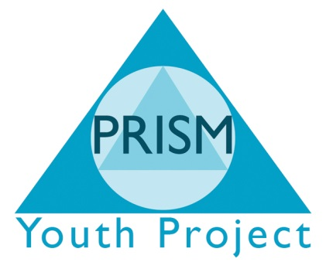

Curriculum Policy
Aim
The purpose of the curriculum is to support young people to:
- Develop a working knowledge of literacy, numeracy and ICT
- Develop knowledge and skills relevant to adult life
- Develop personal, moral and social values alongside a respect for other cultures and religions
- Develop an understanding of the area in which they live, both locally and the wider world
- Take their place in society as informed, confident and responsible citizens.
Outcomes
PRISM independent School will endeavour to provide:
- A safe, supported environment where all young people are able to develop the skills and attitudes which will facilitate continuous personal development.
- A flexible curriculum based over 3 sites which will enable young people to study a holistic package of accredited work covering basic and key skills, personal and social development and a vocational area.
Students with Special Educational Needs
As a school specialising in students for which mainstream school has not been appropriate, PRISM ensures that:
- Staff to student ratio will be no more than 1:5
- Additional 1-1 support is made available within the teaching area’s to ensure all young people have access to a full curriculum
- All young people are encouraged and supported to reach their potential.
Timetable
All students attending PRISM Independent School follow the same basic timetable of lessons and 1-1 work. This includes:
- Basic and Key Skills – Literacy, Numeracy and ICT
- PSD
- Vocational qualification
- Life Skills
During the induction process nd in conjunction with the referring agency and parent/guardian, the young person will chose their vocational subject which informs the site to which they will attend. All other subjects are compulsory.
Qualifications
PRISM Independent School currently offers the following qualifications:
- Entry Level 3 – Literacy – Edexcel
- Entry Level 3 – Numeracy - Edexcel
- Entry Level 3 – ICT – Edexcel
- Level 1 – Literacy - ALAN
- Level 1 – Numeracy - ALAN
- Level 1 – PSD - ASDAN
- Level 1 – PSD - BTEC
- Level 1 – Land Based Studies - BTEC
- Level 1 – Work Skills - BTEC
- Level 1 – Sports and Active Leisure - BTEC
- Level 1 – Construction - BTEC
- Level 1 – Environment and Land Based Diploma – Edexcel
- Level 1 – Land and Environment - BTEC
- Level 1 – Certificate in Progression – NOCN
- Level 2 – Literacy - ALAN
- Level 2 – Numeracy - ALAN
- Level 2 – PSD - ASDAN
- Level 2 – Animal Care – BTEC
Qualifications are reviewed on an annual basis and further courses added to meet demand.

