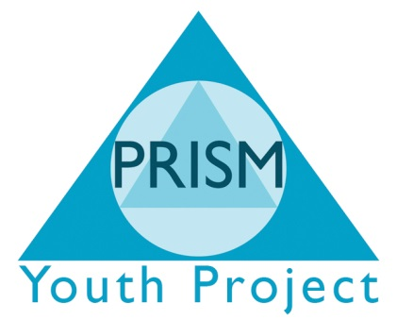

Disciplinary Policy
This disciplinary procedure applies to all staff within PRISM Independent School. This disciplinary procedure exists to ensure that disciplinary problems at work are solved as quickly and as fairly as possible. The disciplinary procedure may be invoked by PRISM Independent School where your work, conduct or action, warrant such a measure and in order to improve performance and working relationships. It is envisaged that most problems of performance and responsibility will be dealt with initially through professional supervision or mutually agreed supervision in order to avoid disciplinary action.
It is envisaged that the employer’s commitment to an open style of management and staff support through regular bi-monthly supervision will mean that recourse to this procedure will be only in the most exceptional of circumstances. Breaches of PRISM Independent School rules, stated guidelines and confidentiality will automatically lead to disciplinary action. All staffs are encouraged to ask through supervision for clarification of any rule, guideline or procedure.
This procedure exists to deal with misconduct wilfully deficient performance, refusal to follow instructions, negligence or similar situations and is intended to be corrective and not punitive.
This procedure has three stages as set out below. At each stage of the procedure you have the right to be represented by your trade union representative, and the right to appeal against any decision taken. At each stage formal records shall be kept and the result of each stage shall be confirmed in writing within the timescales detailed. You are entitled to keep your own records and also to record your disagreements as to the accuracy of the formal records or of the result.
No disciplinary action will be taken against an employee who is a union representative until the circumstances of the case have been notified to a national office, or a full time official of the trade union of which you are a member.
The employee shall be informed in writing of the complaint against them and will be advised in writing of their rights under the Disciplinary Procedure. The employee shall also be provided with documents to be referred to at the disciplinary hearing at least five working days prior to the hearing.
The employee and trade union representative shall be allowed a reasonable time to prepare the employee’s case and the date and the time of any disciplinary hearing shall be agreed between the employee, and the trade union representative and the representatives of the employer.
Any appeals must be made in writing within 5 working days of having received written confirmation of the employer’s disciplinary decision stating reasons for this. PRISM Independent School Director or a panel form the management committee shall hear all appeals.
Stage one – First Verbal warning
This stage of the disciplinary may be issued directly by the line manager. The line manager will explain the reasons for taking disciplinary action and discuss plans and timetables for overcoming the problem. The line manager and employee shall discuss what action should be taken to prevent further disciplinary action and a plan for assistance/training/support/review and appropriate timescales shall be agreed. A verbal warning shall be confirmed in writing. The first verbal warning will remain live on your file for three months.
Stage two – First Written warning
If after the review PRISM Independent School considers that progress on the matter of the first verbal warning is unsatisfactory then a second disciplinary warning may be issued. A plan of action shall be agreed. The warning will confirmed in writing and will remain live on your file for six months.
Stage three – Final Written warning
If after the second review PRISM Independent School still considers that progress on the matter of the second verbal warning is unsatisfactory, then a third hearing shall be called. Following this meeting a final written warning may be issued. This written warning shall clearly state the precise nature of the problem, what improvement/action is required by when, set out a plan for assistance and state that subsequent lack of progress will be result in the termination of employment. The final written warning will remain live on your file for one year.
Gross misconduct
PRISM Independent School reserve the right to dismiss without notice in cases of gross misconduct; examples include:
- Sexual, racial or other serious harassment, including bullying of a fellow employee.
- Using or being under the influence of alcohol or non-prescribed drugs whilst at work, or handling such drugs whilst at work.
- Breaches of procedures for handling cash and other financial transactions.
This list is not exhaustive and will be amended and updated at regular intervals. All staff will be informed of updates.

