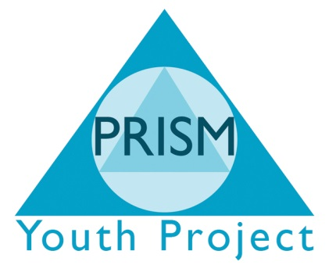

Environmental Policy
Statement
PRISM Independent School is committed to minimising the impact of its activities on the environment.
Our key environment aims are:
- To minimise the use of non-renewable and environmentally-damaging resources
- To maximise recycling
- To increase awareness of environmental issue amongst students and staff
To achieve these aims:
- The Site Coordinators will monitor the progress and compliance of the school’s environment policy.
- The environment will be a termly item on the Site Coordinator meetings.
- The policy will be reviewed annually in line with the review timetable for all PRISM’s policies.
Paper:
- Staffs are asked to keep their written documents to one or two sides of A4 wherever possible.
- Staffs are asked to use double-side photocopying wherever possible.
- Staffs and students are asked to use the paper bin to recycle all paper.
- Staffs and students are asked to ensure that both sides of paper are used before it is recycled.
- Staffs and students are asked not to print documents or websites unless it is absolutely necessary.
- Staffs, students and parents are asked to use the telephone and e-mail wherever possible avoiding copying paper, to colleagues, students or parents.
- Parents are asked to use telephone or email to contact school wherever possible.
Cans:
- Staffs and students are asked to use the green can bins to dispose of all aluminium cans.
Computers:
- Staff and students are asked to ensure that all computers, screens, printers and videos are turned off after use of the day.
Lighting:
- Staff and students are asked to turn off lights whenever they are not being used.
Environmental awareness
- Environmental awareness will be included in the annual programme of assemblies and Personal, Social and Health Education (PSHE).

