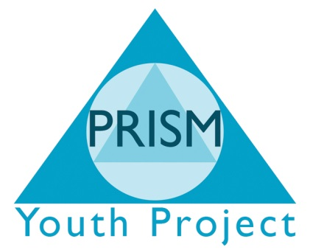

Recycling Policy
- STATEMENT OF INTENT
- PRISM INDEPENDENT SCHOOL promotes environmental awareness. As an organisation we are acutely aware of the day to day ‘rubbish’ generated through its projects and young people waste.
- This policy aims to put in place outlets for the re-use and recycling of waste materials.

- PAPER RECYCLING
- PRISM INDEPENDENT SCHOOL will ensure that all work rooms will have separate rubbish and paper recycling bins.
- All staff will be instructed to use the recycling facilities and educate and encourage the young people to do the same.
- The recycle bin will be emptied on a regular basis into external paper recycle bins supplied by Bradford District Metropolitan Council.
- The external recycling bins are empties once a month by Bradford council.

- TONER/INK CARTRIDGES
- Positive efforts will be made to ensure that all empty toners and ink cartridges are refilled and reused.
- Once the ink cartridges are finished they will be sent to a company who specialises in recycling and passes the profits on to charity.

- GARDEN AND KITCHEN WASTE
- All garden and appropriate kitchen waste is transported to the PRISM City Farm to be used on their compost heap.

- GLASS AND CAN RECYCLING
- At present glass and can recycling is not available in the area.
- PRISM INDEPENDENT SCHOOL have added their name to a list at Bradford Council to receive glass and can recycling bins when they become available.

- GENERAL PONTS
- PRISM INDEPENDENT SCHOOL welcomes feedback and constructive criticism of its recycling and actively looks for other services which will help increases the amount of recycling undertaken.
- The management committee is ultimately responsible for the implementation, monitoring and ongoing development of this policy. The committee will satisfy itself that all staff and committee members are committed to this policy.

