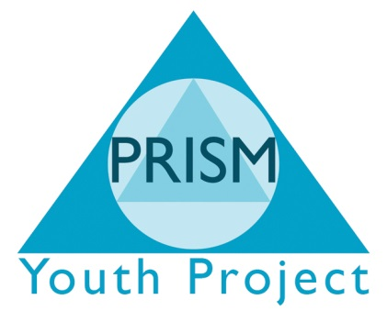

Risk Management Policy
Risk Management
Risk in the context of the PRISM Independent School is
- “The threat or possibility that an action or event will adversely or beneficially affect PRISM’s ability to Achieved its objectives”
- “The safety of young people”
Risk management is the process that provides assurance that, objectives are more likely to be achieved, damaging actions are avoided or minimised and beneficial actions are optimised.
PRISM recognises the need to adopt a risk management approach to ensure systems and processes effectively manage identified risks. The benefits of this approach have been identified as:
- Supports strategic and business planning
- Enhances communication between internal and external partners
- Supports effective use of resources
- Promotes continual improvement
- Helps focus internal audit programme
- Reduces unexpected events and shocks
- Reassures stakeholders
- Minimises crisis management
- Optimises benefit of new opportunities
By ensuring a robust risk assessment form is completed by the staff member and signed off by a member of the Senior Management Team before the engagement of the activity we aim to minimise risk to all concerned.
Minimum Requirements
PRISM’s Board must be assured that there is an ongoing process for identifying, evaluating and managing of all PRISM’s significant risks. The process must be regularly reviewed by the Board and should accord with the requirements of the Charity Commission.
PRISM aims to reflect the good practice in its application of all forms of risk management, with a particular emphasis on child safety.
Responsibility for Risk Management
PRISM’s Management Board is ultimately responsible for ensuring that an effective process of risk management is embedded at all levels within PRISM.
The Managing Director is charged with responsibility for overseeing implementation of the risk management policy. The Executive Head teacher will also be responsible for performance management of the three year strategic plan to provide PRISM with an integrated management tool.
Reporting requirements
The Senior Management Team will formally identify and rate the key institutional risks on at least an annual basis for review by the Management Board. Individual projects within PRISM are also required to review and report on risk management as part the planning process on at least an annual basis. Continual monitoring will be managed through the identification of management action and key risk performance.
The Management Board will also receive regular reports from the Health and Safety Officer.
The Management Board agenda includes a regular item for consideration of risk and controls. The emphasis is on obtaining the relevant degree of assurance that the process and controls are working effectively to identify and manage risk.
Risk Management process
The Risk Register is prepared, reviewed and up-dated on at least an annual basis. This is initiated through:
- A ‘top down’ approach identifying the key institutional risks, derived from the Senior Management perspective and associated with delivery of PRISM’s strategic Plan and organisational strategies.
- A ‘bottom up’ approach whereby planning guidelines and the process of preparing project plans requires all projects to identify key risks specific to their areas together with an action plan to minimise or address any risks.
PRISM considers as part of this Policy the amount and type of risk that is acceptable in the pursuit of its business objectives.
The Risk Register is concerned with the main risks to be managed by PRISM. Informed by national, regional and local developments, competition, changing environment, resources and potential problems or opportunities, identified at all levels within PRISM. It provided the basis for identifying the potential consequences or impact of ignoring the risk or alternatively taking action.
Assessment of the likelihood and scale of impact informs the required management action.
Due diligence and good management practice often dictates that management action is continually taken to manage identified risks. The process is however designed to ensure a systematic documentation of key risks and management actions with identified early warning and performance indicators of effectiveness.
This process of successfully managing risk is fundamental to the success of PRISM and it is essential that all staffs are engaged with the process. The Risk Register and targeted risk improvement plans are disseminated to Projects to facilitate effective and consistent application of management actions. This is supported through a programme of communication, guidance and training to increase awareness of risk management.
Monitoring and Audit
Staff members assigned with responsibility to action risk improvement plans and required to report progress on a regular basis to the Board.
The role of the Senior Management Team is to re-enforce the risk management approach, with the programme of reviews built around the key risks of PRISM.
Individual managers have a responsibility for managing the risks within their specific areas. The remit of the Senior Management Team is to provide reassurance to these managers and the Board that:
- All key risks have been identified
- Appropriate response to managing individual risks has been adopted
- Appropriate and timely action is taken to improve risk management when appropriate
- Decisions to accept residual risks have been taken on an informed basis
Policy review
This policy will be reviewed as part of the annual policy update.

