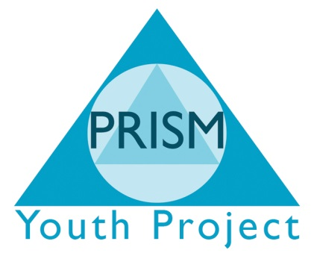

Social Networking Policy
- INTRODUCTION
Social networks are web-based communication structures that enable easy communication and relationship building between individuals via the Internet and smart phone applications, many of which include additional access to further methods of interaction, such as e-mail and instant messaging. While we at PRISM consider the widespread use of social networking applications an effective and useful method for communication in the appropriate context, the potential for misuse by workers, during and out of work hours, is such that the following guidelines are in place.
- PURPOSE OF POLICY
This social networking policy has the following purpose:
- To help protect the organisation against potential liability;
- To give employees clear guidance on what can and cannot be said about the organisation or other workers;
- To help line managers effectively manage employee performance, time management and use of the organisation’s resources;
- To help workers separate their professional and personal communication;
- To comply with the law on discrimination, data protection and protecting the health of employees;
- To be clear about the use of monitoring within the organisation.

- POLICY
Access to email and the Internet is provided during working hours for the purpose of effectively completing work and use must comply with all organisation policies and procedures.
The organisation will not tolerate employees using social networking sites for unofficial or inappropriate uses. Specifically:
- You should not use such sites during contracted working hours for personal interest/benefit, without the authority of an appropriate manager. Usage during your agreed breaks is permitted, subject to the rules contained in this policy;
- You should not at any time upload photographs to your social networking sites of yourself or any other employee taken in a work situation or in a work uniform. No defamatory comments about the organisation should be made on such sites at any time;
- You should not at any time include information that identifies any other employee/contractor/supplier/client/customer or any other individual working in connection with us;
- You should not at any time express opinions on such sites which purport to be the opinion of the organisation, nor comments representing your own views on our organisation;
- Any personal blogs should contain a disclaimer that the views expressed on it are personal views of the author only;
- You should not at any time make comments on such sites which bring the organisation into disrepute;
- You should not at any time make comments on such sites which amount to bullying, harassment or any other detriment towards other employees/contractors/suppliers/young people/customers or any other individual working in connection with us.
The term “use” includes accessing social media by means of PC, mobile phone or by any other device.
You should not use instant messaging whether on a PC or by any other means for personal interest during working hours.
- MONITORING OF SOCIAL NETWORK USE
It is recommended that all employees use strict privacy settings on their social network profiles.
The organisation monitors your internet usage regularly and may undertake more in depth monitoring where considered necessary. This includes monitoring the websites you visit and any other matters referred to in this policy.
- ENFORCEMENT
Any employee who we suspect has breached this policy will be subject to the organisation’s disciplinary procedure.

