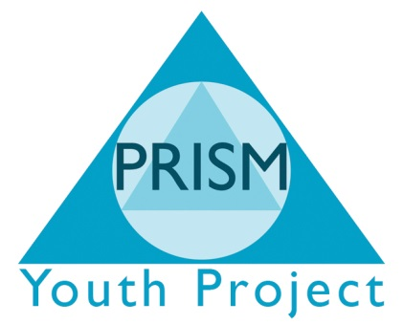

Curriculum Assessment Framework & Policy statement

Curriculum Policy Statement
A dynamic creative curriculum creates opportunities for young people to develop self-esteem, confidence, life skills, team work and communication alongside a vocational subject which allows the young people to achieve their potential.
PRISM Independent School’s curriculum inspires all young people to become:
- Successful learners – who enjoy learning, make progress and achieve
- Confident individuals – who are able to live healthy, safe and productive lives
- Responsible citizens – who make a positive contribution to society.

Unique opportunities for unique young people

