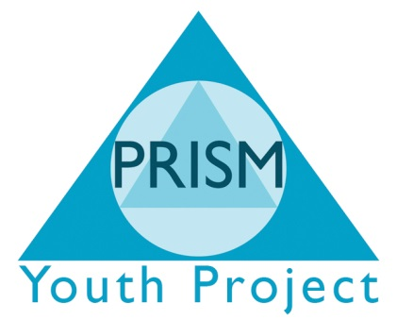

Admissions Policy

Age Range
Prism Independent School is open to learners between the ages of 11yrs and 19yrs (21yrs with MLD).
Pre 16yrs referrals are welcome from schools and other professional bodies, e.g. Social Services, Pupil Referral Units and Youth Offending Teams.

Process for Referral
The referring agency contacts the Assistant Head (for Pre 16yrs) on 01274 487633 for initial discussion re: the suitability of the learner and of Prisms Curriculum Offer.
The referring agency completes the referral form including as much relevant information as possible, which is then returned to the assistant head (for Pre 16yrs) of Prism Independent School.
Once the referral form is received an appointment is made with the referring agency, learner, parent / carer at the site for an initial visit, facilitated by the site Manager. At this visit Prisms’ expectations of the learner are made clear and the learner and parent / carer can ask questions or raise any concerns prior to acceptance of a place.
Once a place is accepted a start date is agreed and the pattern of attendance is finalised.
A referral form is then forwarded to the referring agency.

Suitability:
A learner will be provisionally offered a place if;
- Learner is excluded or at risk of exclusion from mainstream education.
- Learner is on roll at district PRU.
- Learner is statement or is a LAC, and Prism is the best placed body.
- Learner is school phobic.

In the event of over subscription priority is given to:
a) LAC children.
b) Children with SEN.
c) Pupils from within Bradford Metropolitan District area.
Following this we will provide a waiting list.

Unacceptable Referrals
The following will / may preclude a young person from attending;
- History of violence / use of a weapon.
- Offenses against children.
- Animal cruelty (City Farm site only).

On Admission
During the first five days the learner will be allocated a key worker and complete an entrance interview, an individual learning plan (ILP) and a series of base line assessments.
Attendance reports will be sent to the referring body on a daily basis and a reporting schedule will be agreed.

Fees
Standard fees are £50.00 per learner per day.
(Although for multiple placements this is negotiable).

